Union All Transformation:-Three Assignment

1. Source---Three Excel files Emp1, emp2, empl3  
   Destination--SQL Table-Employee table

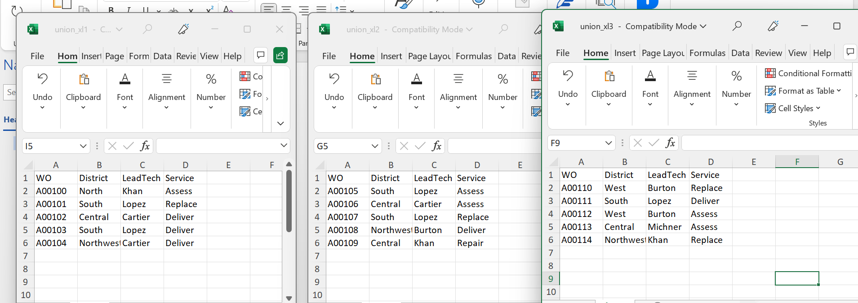

2. Source---Three Excel files Emp1, Flat, SQL Table  
Destination--SQL Table-Employee table

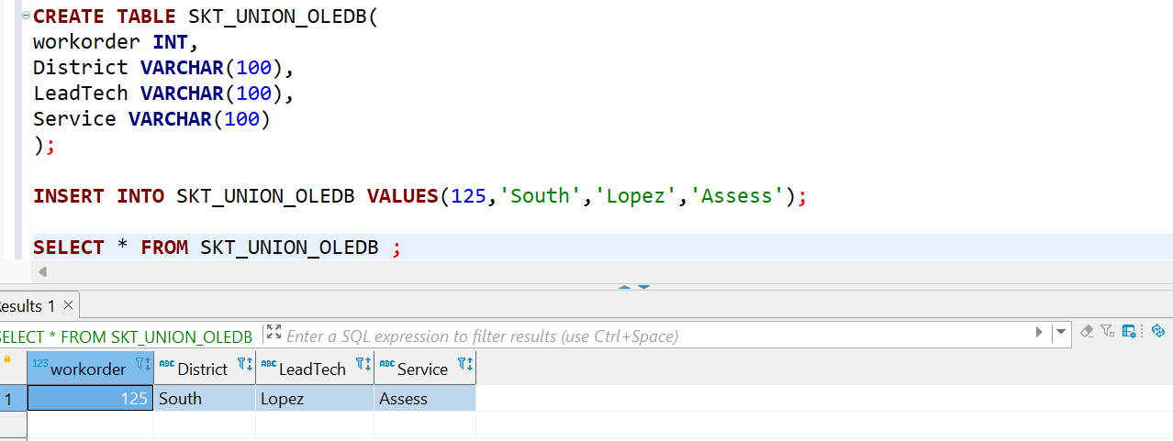

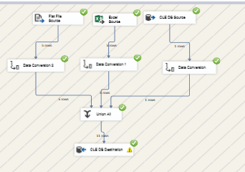

3. Source---Three SQL Table  
Destination--Flat File

THE THREE OLE DB SOURCES ARE

